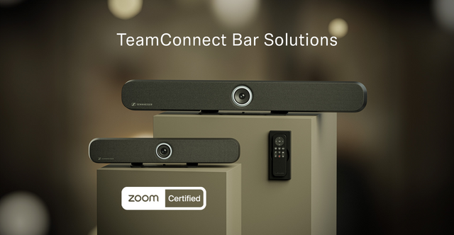

Sennheiser TeamConnect Bars Now Certified for Zoom Rooms
Scalable, all-in-one conferencing devices designed to seamlessly integrate into Zoom Rooms, enhancing meeting experiences

Wedemark, 10 July, 2024 — Sennheiser today announced that its TeamConnect Bars (TC Bars) are now Certified for Zoom Rooms. This certification enables Zoom users to conduct hybrid meetings with superior Sennheiser audio and 4K Ultra HD video. Sennheiser TC Bars enhance Zoom Rooms by delivering crystal clear sound and superior video quality, ensuring all participants are seen and heard perfectly. The seamless integration between TC Bars and Zoom supports flexible and reliable meeting solutions, catering to diverse hybrid work environments. By using certified Sennheiser devices, organizations can create an efficient and effective collaboration space, whether participants join from the office, home, or other remote locations.

Zoom is a leading collaboration and conferencing platform, known for its focus on innovation and delivering features that meet customer needs. With offices adopting various definitions of hybrid work, IT managers are creating meeting spaces with flexible conferencing solutions for every type of meeting. These spaces demand reliable AV and UC solutions that enhance the collaboration experience. The Sennheiser’s certification confirms that TC Bars ensure every meeting participant is seen and heard while making the setup process straightforward and effective.

“We are excited that our TeamConnect Bars are now Certified for Zoom Rooms,” said Charlie Jones, Sennheiser’s Global Alliance and Partnership Manager. “Zoom Rooms are a great addition to modern workspaces, offering flexible and reliable solutions for hybrid meetings. Our new TeamConnect Bars provide superior audio and video quality, enhancing the overall meeting experience and ensuring seamless integration with Zoom Rooms.”

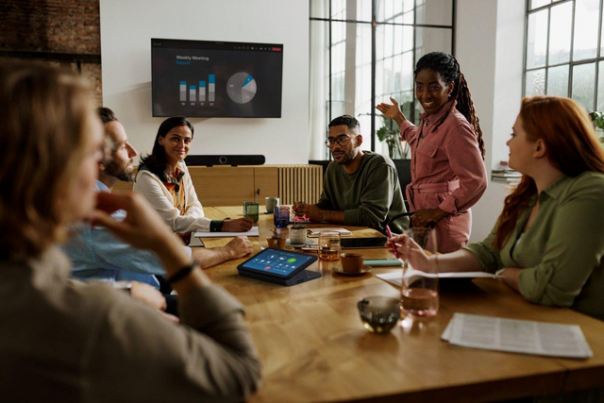

As the latest additions to the Sennheiser TeamConnect Family, the TC Bars are available in two models to suit varying meeting room sizes — the TeamConnect Bar S, featuring four microphones and two speakers for small meeting rooms and collaboration spaces, and the TeamConnect Bar M, equipped with six microphones and four speakers for mid-sized meeting rooms and collaboration spaces.

TC Bars are plug-and-play devices, enabling users to start meetings quickly via USB. Integrated beamforming technology, the same technology found in the TeamConnect Ceiling solutions, allows freedom of movement and seamless transitions between presenters. The full-range stereo speakers ensure natural speech and outstanding intelligibility. Superior audio is complemented by a camera with advanced AI features, including auto framing and person tiling.

Additionally, the TC Bars offer flexible and scalable room setups with an onboard Dante port for extension mics and an option to add an external USB camera, catering to rooms requiring broader coverage. Multiple mounting options and remote management via Sennheiser Control Cockpit simplify integration into any space.

Sennheiser continues to develop solutions compatible with Zoom Rooms, strengthening its commitment to provide users with exceptional meeting experiences. To learn more about the TC Bars and other TeamConnect solutions, visit www.sennheiser.com.

(Ends)

About the Sennheiser brand
We live and breathe audio. We are driven by the passion to create audio solutions that make a difference. Building the future of audio and bringing remarkable sound experiences to our customers – this is what the Sennheiser brand has represented for more than 75 years. While professional audio solutions such as microphones, meeting solutions, streaming technologies and monitoring systems are part of the business of Sennheiser electronic GmbH & Co. KG, the business with consumer devices such as headphones, soundbars and speech-enhanced hearables is operated by Sonova Holding AG under the license of Sennheiser.

www.sennheiser.com
www.sennheiser-hearing.com

Global Pro Audio Press Contact
Jeff Horan
Jeffrey.horan@sennheiser.com
+1 860-598-7539

